Ethical Quality in eHealth: A Challenge with Many Facets
M. Rissanen, Aalto University School of Science, Finland
Abstract. In eHealth, ethical quality refers to several other quality attributes. Understanding its versatile nature helps designers consider ethical requirements better in design processes. This can change the nature of a design process in a more pragmatic direction enhancing this way the total quality of products and services. The significance of ethical quality in eHealth increases also because the nature of given services changes rapidly. The growing number of distance-based services is one example. In the study, theoretical frames for design are considered in terms of ethical quality with a content analytical approach.
Keywords: eHealth, ethical quality, theoretical frames of design.
- Introduction
Ethical quality in eHealth projects has a significant role. There are many ethical codes for the eHealth area. These codes reflect different aspects of quality. Ethical quality attributes reflect customer, product, and process quality issues. In addition, ethical quality affects efficiency, image tasks, and broader societal issues. When the versatile essence of ethical quality is in focus more intensively, its control and management in eHealth projects may have a more pragmatic nature.
Many eHealth services are typical for applications of distance education and consumer support (e.g., applications for self-health management). Thus, e.g., many customer-targeted eHealth applications serve a venue for interactive knowledge processing between customers and health professionals without the need for clinic appointments. The question is not only about educational aspects but also about distance operational protocols. This fact also increases the demand level of many applications and not least in the ethical sense.
The study focused on the content and meaning of ethical quality in eHealth and its connection to other quality attributes. When ethical requirements are considered in the context of common quality facets, a wider perspective on ethical quality can be reached in the eHealth area. As well, aspects which are somehow hidden can be realized as ethical parameters more easily.
- Methods
The theme area is examined by literature review which covered articles from areas of eHealth ethics, quality management, and eHealth design. Findings are considered with critical and content analytical approach. The study represents design science and concentrated on quality theoretical frames of design in eHealth. The role and meaning of ethical quality in eHealth in this frame combination formed the research focus. Quality theoretical considerations in general form an essential frame area of theoretical problem analysis in eHealth design.
- eHealth Innovations and Ethics
Designing innovations in eHealth requires thinking about quality, which considers quality attributes and especially ethical aspects from view of versatile quality. Sophisticated evaluation is necessary for successful eHealth [1]. Ethical requirements must be considered when the first design ideas occur during the product planning phase [2]. Ethical acceptability of innovations means an always distinctive rule: If the idea in question is ethically acceptable and reasonable sustainability is predictable, then the continuous development and generation of the idea is meaningful. However, ethically non-acceptable ideas should be rejected during the idea phase or reconsidered and developed so they are ethically acceptable. This ethical evaluation is a process that might require a team with ethical expertise to define the potential of the presented product ideas even in the early developmental idea phase. If this early ethical evaluation is neglected, many resources are used perhaps in vain. Ethical quality today forms a more important aspect in eHealth design policy. When the product reflects innovation quality in eHealth area, its importance is understandable and its principle in balance with ethical requirements and therefore innovativeness and innovation quality are not equal concepts in this area [2]. However, ethical acceptability of eHealth products means in many cases maturation and validation iterations.
- Ethical codes and emphasized ethical attributes
There are several ethical codes for eHealth. The foundation for ethical eHealth codes comes partially from the four principles approach for biomedical ethics [3]. The collection of ethical principles of the European Group on Ethics in Science and New Technologies (EGE) [4], [5] also forms the foundation for this theme area. This list contains the following aspects: respect for privacy and for the security of personal health data, confidentiality, trustworthiness, legitimacy, patient’s informed consent for data use, transparency of standards, and patient access to electronic health records (EHRs). In principle, the same attributes get attention in most of the codes. However, some aspects are differently emphasized, and some aspects are unique. The Internet Healthcare Coalition (IHC) [6] emphasizes principles such as candor and trustworthiness, quality of the medical information content and services, informed consent, privacy and confidentiality, and high-quality commercial and professional practices. Quality, efficiency, education, and individualized care are the main ethical issues in the URAC Accreditation Guide (URAC) [7]. The HONcode covers authoritativeness, complementarity, privacy, attribution, justifiability, transparency, financial disclosure, and sponsorship [8] and was generated as an internal process in consultation with webmasters, information providers, and health consumers [9]. The principles of the Hi-Ethics Coalition contain the same attributes and also pay attention to consumer feedback (consumers’ ability to evaluate the quality of the information), professionalism, data protection, and third party rating systems [9], [10]. eHealth Code of Ethics (eHealth) [6] emphasizes synergy creation among different entities, data quality and protection, self-evaluation, consumer and provider education [9]. Content, privacy, confidentiality, E-commerce, advertising, and sponsorship are underlined in the code of the American Medical Association (AMA) [9], 11], and broader consumer education and co-operative evaluation are mentioned in the European Union (EU) Action Plan (MedCERTAIN) [9], [10]. Anonymity requirement is emphasized in ISO/IEC (15408) [12] standard. There are also ethical issues addressing eHealth cloud management and computing.
Ethical attributes are also summarized and grouped into fewer categories. For example, Khoja et al. [13] collected and listed ethical and legal issues in their structured literature review. This list contains the following issues: management of health information on the Internet, health information privacy, consent for care in eHealth, medical malpractice liability, patient’s right to access information, security of information during portability, control of malpractice, and cultural issues in communication. Miesperä et al. [14] collected features from this substance area in their literature review in six main areas: attributes of autonomy, privacy, confidentiality, consent, equality of service availability, and beneficence.
- Ethical Quality and its reflect the other Quality Dimensions
  - Pondering Ethics and Customer Quality
In general, customer quality refers to aspects that are important for consumers. Customer values also mean a more competitive advantage [15]. The recognized ethical dimensions refer in the first place to customer quality. The quality of the information content, accessibility, anonymity, respect for autonomy, discrimination, free and informed consent, justice, privacy and data protection, and safety represent all also customers’ interests.
Customer activity and customer consideration form an area which is tried to support intensively with new eHealth innovations. In addition, customers’ ideas may represent remarkable innovation [16], which may be valuable in new areas. The problem is that customers’ opinions are heard typically when new products are at hand and when the first versions are tested or when the new products are in the market. When cost-intensive projects are planned which change service protocols in a remarkable way, it is reasonable to secure channels for the “customers’ voice” and widen in this way also customers’ rights. In this way, consumers have a greater role in evaluating new plans and ideas or give feedback when new products are planned for managing consumers’ health, for example [2]. Consumers’ role as an inspirational source for new products is therefore typically nowadays too limited. Often, there are not open and flexible channels where consumers can provide wishes and ideas freely to organizations and health policy designers or product designers. When the target is to reach the best professional practices, consumers’ ideas about these processes should have a greater role. However, also customers’ ideas and desires need their ethical evaluation iterations. Which ideas and desires are ethically acceptable, worthy, and possible to realize, and what are the wider reflections on society and the healthcare system?
Customers should also have rights in terms of options. Innovations in eHealth area change the healthcare system in many ways, but are all changes useful for or rewarding to all customers and aligned with their values? Acceptability must take place also at the individual level.
  - Ethics and Its Requirements for Product and Process Quality
All aspects that refer to customers’ rights and requirements in the ethical sense are naturally challenges for production and product quality and form the essential focus when ethical principles are introduced into the design and design policy. In addition, the guidelines design and production line must develop self-evaluative protocols that guarantee that given requirements will be considered. In common quality terminology product quality refers to product features, performance, and perceived quality [17]. Production quality refers to design process and its evaluative protocols [18]. Beneficence and nonmaleficence means that “the eHealth tool should perform in a way that benefits the user” without causing harm [19]. This requirement refers to customer quality, but also represents challenges for production and process quality. This requires that production policy is controlled, and the quality of a product is evaluated in a versatile way. Product quality and ethical quality are not separate aspects. Content quality e.g., is also an ethical task. It is customers’ right that the knowledge offered is trustable and right. Also, quality evaluation in this area is not a straightforward task; e.g., “quality remains an inherently subjective assessment, which depends on the type of information needed, the type of information searched for, and the particular qualities and prejudices of the consumer” [20].
Connected processes for system use must as well be carefully designed, controlled, followed, and evaluated. It is not enough that the product contains all given ethical requirements. The product must be evaluated in its use context, which includes connected processes. Thus, the purpose is to evaluate how well this product-process combination finally fulfills given ethical requirements and could serve customers’ needs. The term dignity is often used when “the rights of elderly people” [19] are in question. Customer dignity is a principle which should be underlined in all design plans in this area. The product, connected processes, and customers form an entity and a chain that should be evaluated with deep enough sensitivity what comes to given ethical requirements. Beneficial products and services require attention to the process, product, and customer quality categories. Does the product deploy ethical principles, do the connected processes support these ideas, and are customers’ reactions and ideas heard in a sensitive manner? Hence, novel products may be innovative in this area, but if they miss an ethical acceptability or when innovativeness is connected only with the technology change without real benefits, innovation quality is then questionable [2].
  - Ethics and Image Issues
Image is a product of communication, marketing, and production. Product image has a remarkable effect on consumer behavior [21] and innovation diffusion [22] and thus has an effect on a product’s success in the market. The product image should be re-evaluated when allocation decisions are in question just to prevent too straightforward and unconsidered decisions in product procurement policy. Ethical quality in eHealth emphasizes “beneficence.” However, “evidence for the beneficial impact of many eHealth technologies is still absent or at best only modest” [23]. Thus, image evaluation is a part of the ethical quality process. Evidence of trustworthiness does not mean only risk and performance of the system but also contains interactional and context-based information [24].
  - Ethical Issues and Efficiency
Resource allocation as an ethical task has also raised discussion in eHealth. Health consumers should have the opportunity to use online health services safely and effectively [25], and “public resources should be used fairly and efficiently” [26]. Public resources must be used in a way that produces a good return on investment (ROI). Thus, ethical considerations that are linked to cost intensity should take place when cost-intensive development projects are planned or when such allocations are funded with public resources. The question involves evaluation of alternative costs and fairness in prioritizing: How to allocate limited resources? Which development projects must be prioritized? In the health area, estimates and scenario planning that try to predict future trends in cost-intensive IT projects are usually demanding. Thus, eHealth technologies should be evaluated with a comprehensive set of measures [23]. These evaluations are part of the ethical quality process and its evaluation. Priority policy in health sector should be justified. Therefore, the questions of service intensity and option policy in healthcare are also questions of ethical nature. Which amount of service capacity will produce high-quality services in each area, and how can eHealth strategies help guarantee optimal care intensity?
  - Ethical Issues and Mission Fitness
Every eHealth project and product has an intended mission, and this mission must be transparent and obvious to the focus organization. Transparent and obvious mission means that mission clarity is acquired. If design ideology produces products that are aligned with the organization’s values and mission statements, then mission fitness can be acquired [27]. However, this is not enough.
“Values have always implicitly driven the decisions of the organization” [28]. Mission statements for IT policy and IT products in eHealth must follow ethically acceptable values. This value filtering needs continuous evaluation; are these controlling values sustainable and acceptable? Thus, in this area mission formulation in organizations and in IT companies must recognize mission strategic considerations as tasks that are closely connected to ethical issues. In addition, this acceptability must be evaluated from the perspective of customers and their rights, by understanding the requirements of the product and process quality, and the economic consequences and societal impact. Only if mission statements are formulated by following truly ethical and quality requirements widely can we speak about acceptable mission quality. Table I shows the connection between quality areas and ethical principles.
Table 1. Quality Areas and Connected Ethical Principles in eHealth Area
Quality facet | Ethical core principles
Mission | Equality of availability,  High-quality products and processes following ethical principles
Customer | Perceived: autonomy, privacy, confidentiality, service availability beneficence, consent
Product | High-quality products deploying given ethical requirements
Process | High-quality processes supporting given ethical requirements
Production | Production & maturation policy following given ethical guidelines
Efficiency | Cost-effective services and justified priority policy
Innovation | Innovation quality in balance with ethical requirements
Image | Trustworthiness in communication policy, image evaluation
- Discussion and Conclusions
Ethical quality affects other quality attributes. However, this reflection means a two-way effect. As well, it is useful to concentrate on separate quality areas and to identify those requirements which are closely connected to ethical aspects. Usefulness and safety are attributes of product quality but as well challenges for ethical design. Service satisfaction refers to customer quality but is as well a challenge in ethical sense. Trust is associated as a product quality and an image quality factor but forms also an ethical requirement. In this way also separate quality areas form inspirational and iterative source for ethical considerations. New, identified requirements e.g., of customer quality need consideration of connected ethical aspects and in this way connect with ethical scheme (see Fig. 1). Understanding the versatile nature of ethical quality is essential. It helps designers understand and integrate ethical requirements better in a design process. This can change the nature of a design process in a more pragmatic direction. Evaluating also process outcome [29] is essential in eHealth. New innovations need evaluation in sense what are their social influence and reflections to the whole health care infrastructure. High value for patients should mean improved outcomes and good health [30]. Product maturation and validation means in eHealth area iterative production cycles. Development and research means typically continuous cycles of design, enactment, evaluation, and redesign [31] and this affects also maturation procedures which concern ethical acceptability of eHealth products.
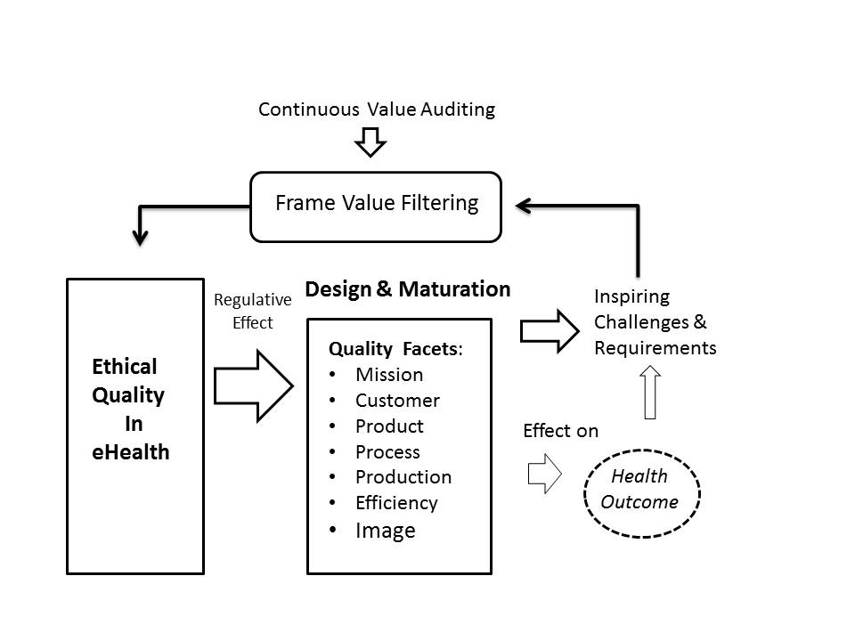Fig. 1. Ethical issues as regulatory factors in eHealth maturation.

The significance of ethical quality in eHealth grows all the time because eHealth innovations get more features and change their nature. For example, when eHealth services are distance based, issues of security play an important role. If the deep connection between ethical quality and other quality attributes is realized and considered in a design process, more quality for products and services can be embedded. One target of ethical quality is to produce the best professional practices. However, there is also evidence that in eHealth “best practice guidelines in effective development and deployment strategies are lacking” [23]. Consequently, if ethical quality requirements are approached by integrating ethical requirements and their reflections in all relevant quality areas and by understanding also the complexity of this challenging area, then more pragmatic design guidelines can be expected. Beside general guidelines also project based considerations are necessary.
References
- Ammenwerth, E., Aarts, J., Berghold, A., Beuscart-Zephir, M.C., Brender, J. et al.: Declaration of Innsbruck. Results from the European Science Foundation Sponsored Workshop on Systematic Evaluation of Health Information Systems (HIS-EVAL). Methods Inf. Med. l(45), Supplement 1, 121-123 (2006)
- Rissanen, M.: Prioritizing Quality Attributes in eHealth Design. Leading Transformation to Sustainable Excellence. 7th Quality Conference in the Middle East. Proceedings. Dubai 2014. 133-142 (2014)
- Beauchamp, T.L., Childress, J.F.: Principles of Biomedical Ethics, 5th ed. Oxford University Press, New York (2001)
- European Commission. Opinion of the European Group on Ethics in Science and New Technologies. Ethical issues of healthcare in the information society, 13, (1999), http://ec.europa.eu/bepa/european-group-ethics/docs/avis13_en.pdf
- European Commission. Press release of the European Commission Secretariat-General Directorate C, Secretariat of the European Group on Ethics in Science and New Technologies, http://ec.europa.eu/bepa/european-group-ethics/docs/cp13_en.pdf
- California Health Care Foundation. Proceed with Caution: A Report on the Quality of Health Information on the Internet Complete Study, http://www.chcf.org/~/media/MEDIA%20LIBRARY%20Files/PDF/P/PDF%20ProceedWithCautionCompleteStudy.pdf
- Utilization Review Certification Commission. Health Web Site Accreditation Guide, Version 3.0, http://www.urac.org/docs/programs/URACHW2.1factsheet.pdf
- Health On the Net Foundation. Certification Process, http://www.hon.ch/HONcode/Webmasters/StepByStep/StepByStep.html
- Risk, A., Dzenowagis, J.: Review of Internet Health Information Quality Initiatives. J. Med. Int. Res. 3(4), e28 (2001)
- Coiera, E.: Information Epidemics, Economics, and Immunity on the Internet. We Still Know so Little about the Effect of Information on Public Health. Brit. Med. J. 317, 1469 (1998)
- Winker, M., Flanagin, A., Chi-Lum, B., White, J., Andrews, K., Kennett, R., DeAngelis, C., Musacchio R.: Guideline for Medical and Health Information Sites on the Internet. J. Am. Med. Assoc. 283(12), 1600-1606 (2000)
- ISO/IEC Standard 15408 (2009)
- Khoja, S., Durrani, H., Nayani, P., Fahim, A.: Scope of Policy Issues in eHealth: Results from a Structured Literature Review. J. Med. Internet Res. 14(1), e34 (2012)
- Miesperä, A., Ahonen, S.M., Reponen, J.: Ethical Aspects of eHealth- systematic Review of Open Access Articles. Fin. J. eHealth eWelfare. 5(4), 165-171 (2013)
- Poter, M.: Competitive Advantage. Huaxia, Beijing (1998)
- Magnusson, P., Matthing, J., Kristensson, P.: Managing User Involvement in Service Innovation: Experiments with Innovating End Users. J. Serv. Res. 6(2), 111-124 (2003)
- Tenner, A., DeToro I.: Total Quality Management. Three Steps for Continuous Improvement. Addison-Wesley, Reading (1992)
- ISO 9001: Quality Management Guidelines. (2008)
- Wadhwa, K., Wright, D.: eHealth: Frameworks for Assessing Ethical Impacts. In George, C., Whitehouse, D., Duquenoy, P. (eds.) Legal, Ethical and Governance Challenges. pp.183- 201. Springer-Verlag, Berlin (2013)
- Wilson, P.: How to Find the Good and Avoid the Bad or Ugly: a Short Guide to Tools for Rating Quality of Health Information on the Internet. BMJ. 324(9), 598-600 (2002)
- Quester, P., Karunaratna, A., Goh, L.: Self-congruity and Product Evaluation: A Cross-cultural Study. J. Consumer Marketing. 17(6), 525-535 (2000)
- Moore, G., Benbasat, I.: Development of an Instrument to Measure the Perceptions of Adoption and Information Technology Innovation. Information Systems Research. 2(3), 192-222 (1991)
- Black, A., Car, J., Pagliari, C., Anandan, C., et al: The Impact of eHealth on the Quality and Safety of Health Care: a Systematic Overview. PLOS Med. 8, e1000387 (2011)
- Nickel, P.: Ethics in e-Trust and e-Trustworthiness: The Case of Direct Computer-Patient Interfaces. Ethics Inf. Tech. 13, 355-363 (2011)
- Nuffield Council of Bioethics. (2010)
- Hood, C., Bougourd, S.: The Ethics of e-Health. Int. J. E-Health Med. Commun. 2(2), 82-85 (2011)
- Rissanen, M.: Machine Beauty- Should It Inspire eHealth Designers? In: Zhang, Y., Yao, G., He, J., Wang, L., Smalheiser, N., Yin, X. (eds.) Health Information Science, Third International Conference, HIS 2014, Shenzhen, China, LNCS vol. 8423, pp. 1-11. Springer, Heidelberg (2014)
- Sapienza, A.: Creating Technology Strategies. How to Build Competitive Biomedical R&D. Wiley-Liss, New York (1997)
- Donabedian, A.: An introduction to Quality Assurance in Health Care. Oxford University Press (2002)
- Porter M.: A strategy for health care reform- Toward a Value-based System. The New England Journal of Medicine. 361, 109-112 (2009)
- Design-Based Research Collective.: Design-based Research: An Emerging Paradigm for Educational Enquiry. Educational Researcher. 32(1), 5-8 (2003)

